
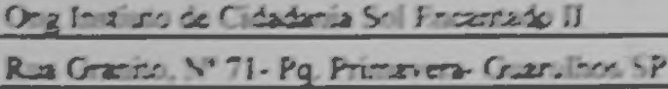
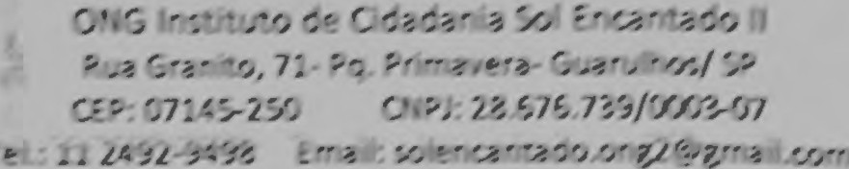
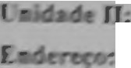
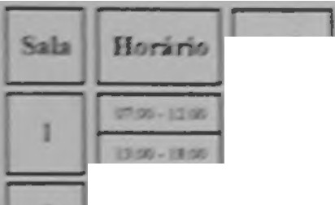
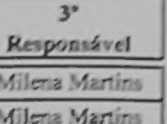

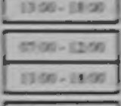
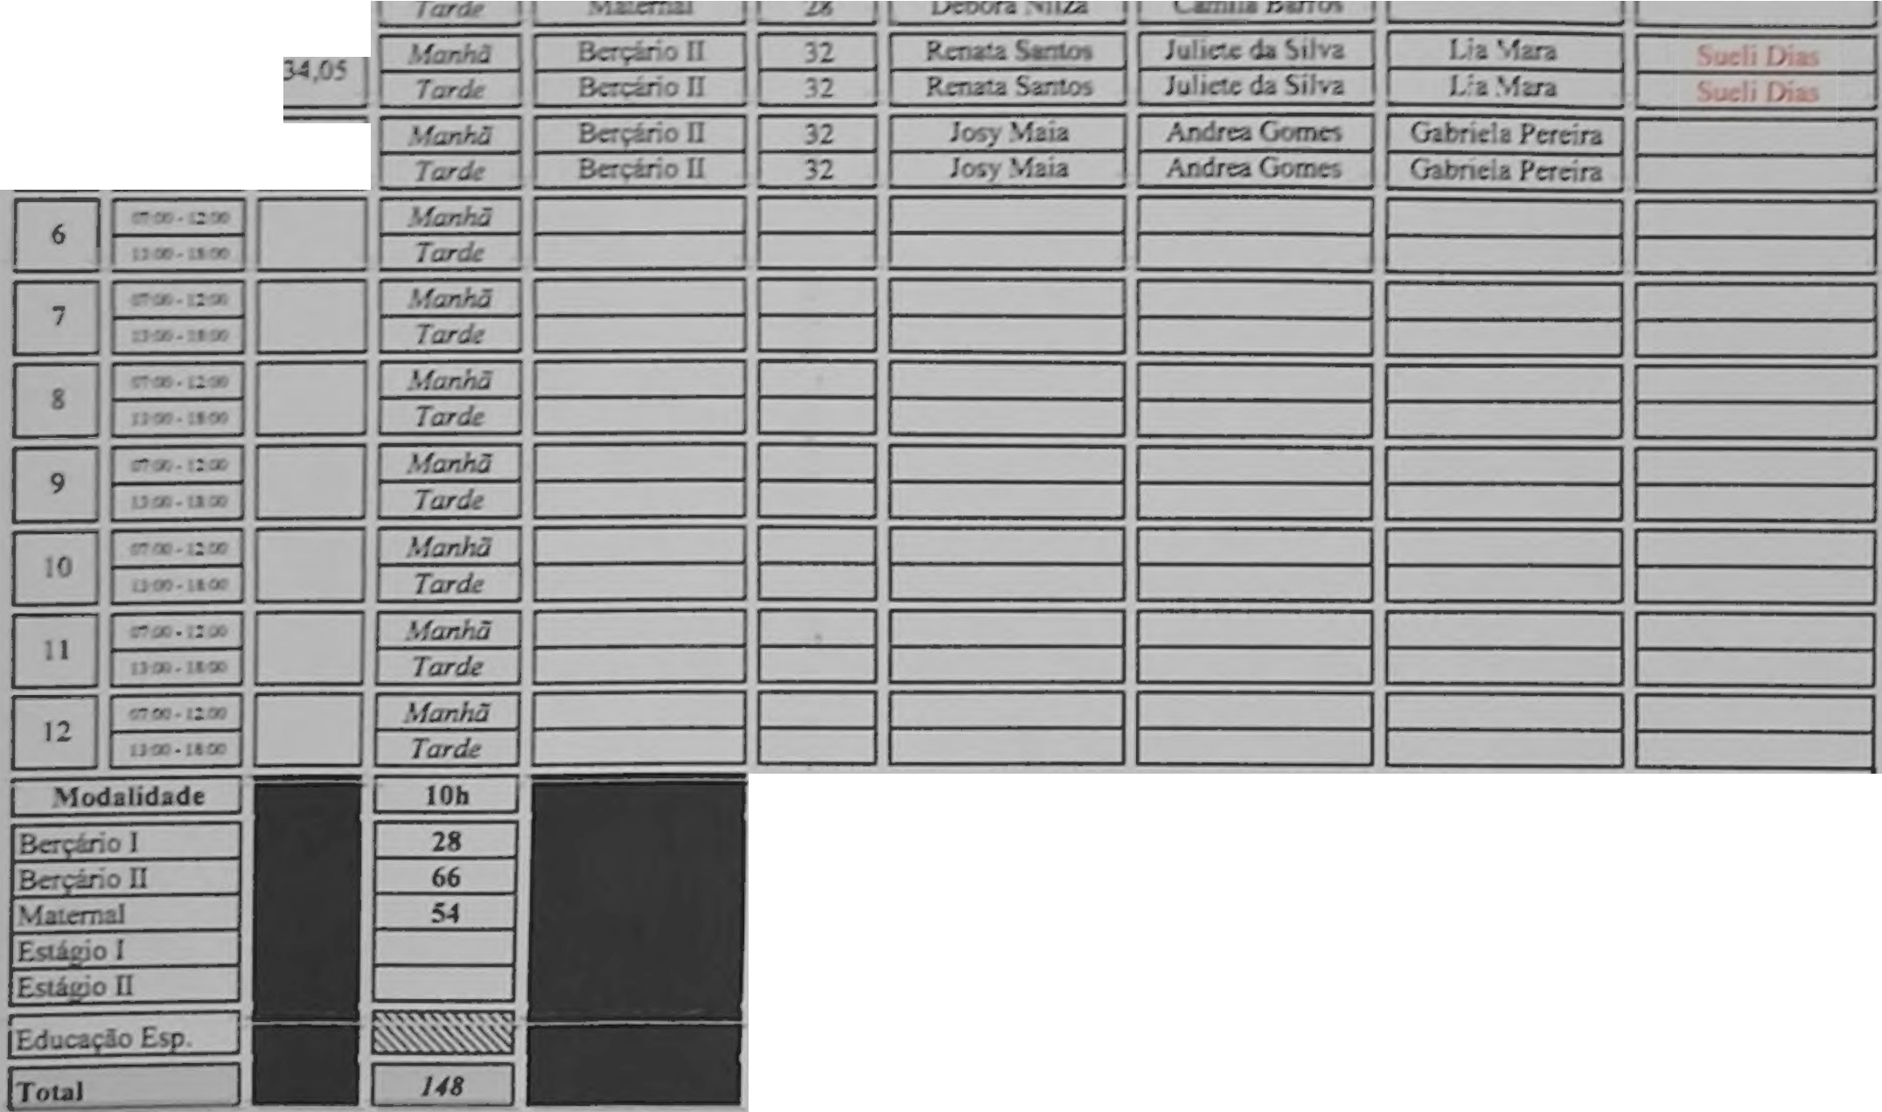

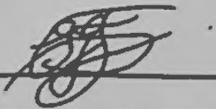
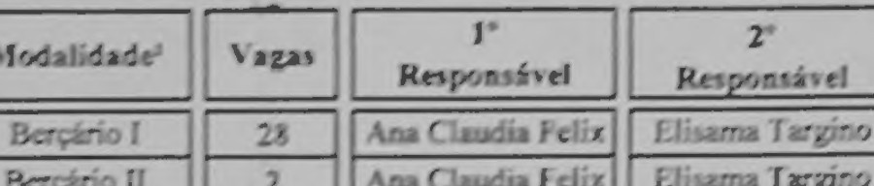
A....J:XO Ili. E/JlCAÇÃO /...:fA.'-'f/1, • CR/;C/IL
OUDdrr, d,, r la\• P<. ,, ()r,c..,nr,, -2112 �
\•d� ,·a11a• r,,ra/
1
- "
, ==l- = =::::;::=== ===
===
======= =========�i========
, --:-, .:� 1
'·'·-�-"'
._ _
---1:J ',:1------ _,;.......::e:; 1---------' ------' 1-------' 1
0-3-3.!1
0S/08/2025
Guarulhos.
Elillijtu1e 1k Ramú"'11 S111111n
úirctor-Coorocnaoor hdagogico
RG 8 J66 175
Clcllia lzaocl fc1xcir.1 de 5,qu�ira
RG •13 490 608-1

